CS 1101-01 Programming Fundamentals - AY2023-T3

Learning Journal Unit 1

Part One:

Question 1:

>>> print(Hello’)

Output:

SyntaxError: invalid character '’' (U+2019)

>>> print(Hello)

Output:

NameError: name 'Hello' is not defined

Explanation:

Python cannot read strings without a double or single quotation.

Question 2:

>>> 2++2

Output: 4

>>> 2—2

Output: 4
>>> 2+-2

Output: 0
>>> 2-+2

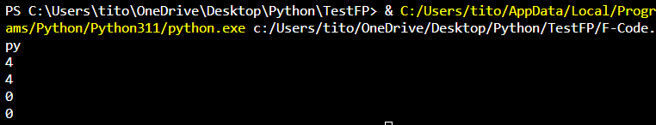
Output: 0

Explanation:

First operation, In Python 2++2 or 2+2 or 2+++2 like a 2+ (+2) =4 in math in the previous input, there are no brackets, but Python adds them automatically

In second operation, this is also like the previous example. Python will also put it in brackets and calculate it like this:

2-(-2) =2.

The third and fourth operations like were normally like a calculator.

Question 3:

>>> print(02)

Output: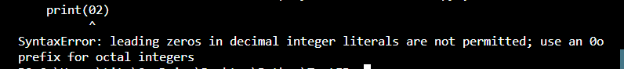

This SyntaxError because leading zeros are not allowed in Python.

Question 4:

>>> 6 6

Output:

SyntaxError: invalid syntax. Perhaps you forgot a comma?

In Python, you cannot put two values ​​without a comma, so this is a syntax error

Part Two:

>>> print(1+1,”1+1”)

Output: 2 1+1

Through this experience, it is clear that I can print leading zeros in Python like this:

>>> print(“01”)

Output: 01

It appears to be a number and it appears to be a zero at the beginning, but it is not a number. It is a String, and the evidence for this is evident in the previous example above, where the first two values ​​were printed after adding them and the second two values ​​were printed as they are because Python considered them a String and not an integer

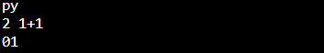
References:

Downey, A. (2015). Think Python: How to think like a computer scientist. Green Tea Press. https://greenteapress.com/thinkpython2/thinkpython2.pdf

